### Online Examination System

*Submitted in partial fulfillment of the requirements*

*for the award of the degree of*

**Bachelor of Computer Applications**

To

Guru Gobind Singh Indraprastha University, Delhi

Guide: Submitted by:

Govind Upadhayay 1. Ankit Mishra 015

2. Devanshi tyagi 029



**Nurturing Excellence**

**Institute of Innovation in Technology & Management**

**New Delhi – 110058**

**Batch (2018-2021)**

##### Certificate

We, 1. *Devanshi tyagi* (02990302018) & 2. *Ankit Mishra* (01590302018) certify that the Summer Training Project Report (BCA-355) entitled “*Online Examination System*, OE” is done by us and it is an authentic work carried out by us at Institute of Innovation in Technology & Management. The matter embodied in this project work has not been submitted earlier for the award of any degree or diploma to the best of my knowledge and belief.

1. Signature of the Student 2. Signature of the Student

Date:

Certified that the Project Report (BCA-355) entitled “***Online Examination System*, OE**”

done by the above students is completed under my guidance.

Signature of the Guide

Date:

Name of the Guide: Mr. Govind

Upadhaya (Ass. Prof.)

Designation:

Countersigned

Director

***Acknowledgement***

The completion of the project “Online Examination System” involves contribution and assistance from many individuals. It is our pleasures to thank our guide “Govind Upadhyay sir” to train us. The project would not be a success without his constant and valuable guidance. His dedication, collaboration and interaction were key factor in the success of my project. Through this column, it would be our utmost pleasure to express our warm thanks to him for his encouragement, co-operation and consent, without that might not be able to accomplish this project.

We are greatly indebted to all teachers for their kind assistance in the journey of making this project a successful one.

**TABLE OF CONTENTS**

|  |  |  |
| --- | --- | --- |
| **S No** | **Topic** | **Page No** |
| 1. | Certificate | II |
| 2. | Acknowledgements | III |
| 3. | List of Tables/Figures/Symbols | IV |
| 4. | Chapter-1: Introduction | 7 |
| 5. | Chapter-2: System Analysis | 9 |
| 6. | Chapter-3: System Design | 17 |

**LIST OF TABLES**

|  |  |  |
| --- | --- | --- |
| **Table No** | **Title** | **Page No** |
| 3.1 | Login table | 29 |
| 3.2 | Registration table | 29 |
| 3.3 | Question answer table | 30 |
| 3.4 | Feedback table | 30 |

**LIST OF FIGURES**

|  |  |  |
| --- | --- | --- |
| **Figure No** | **Title** | **Page No** |
| 2.1 | Prototype Model | 15 |
| 3.1 | Block Diagram | 17 |
| 3.2 | Use-case diagram | 18 |
| 3.3 | 0 –level DFD | 19 |
| 3.4 | Data Flow Diagram | 19 |
| 3.5 | ER- Diagram | 21 |
| 3.6 | Site –map | 22 |
| 3.7 | Input screen | 23 |
| 3.8 | Output screen | 24 |

**SYNOPSIS**

**Online Examination System**

**Introduction**

During this time of pandemic situation where students are unable to attend their exams, Online Examination System comes into play.As it is difficult for colleges to conduct exams Online Examination system makes it easier. Online examination system is a software solution, which allows a particular institute to arrange, conduct and manage examinations via an online environment. Teacher can upload questions for exam purposes according to their subjects.This System allows the students to not only appear in the exams but also to take 30 minutes’ quizzes to practice for their exams. Results will be generated at the end of the exam. Students don’t have to wait to get their result. As soon as the exam is over the next screen will be the result screen. Students will find blogs at the end of the website which will help them to boost themselves for studies. Tips for better marks, self-confidence build up techniques, and interesting facts are all part of the blog. Anyone can ask any question through the feedback (contact) page.

* **Objectives:**
* To create a platform for online examination.
* To ease the work of teachers.
* To maintain data
* To make the exam system digital

**Project Category**

Web based system.

**Tools / Platform, Hardware and Software Requirement specifications.**

**Hardware Requirement Specifications**

* 2 GB RAM
* VGA monitor
* Intel 3.0 GHz or higher processor
* Keyboard and mouse
* Printer

**Software Requirement Specifications**

* Operating system - Windows (7/8/10)
* Web browser
* Visual Code editor
* Eclipse IDE 2020-03
* Apache Tomcat Server

**Are you doing this project for any Industry/college? Mention Yes/No. If Yes, Mention the**

We are doing this project for **our college.**

**Name and Address of the Industry or Client.**

*Institute of Innovation in Technology and Management. (IINTM)*

**Future scope and further enhancement of the project. Also mention limitation of the project.**

**Further enhancement:**

- to add quizzes and all the subjects of courses shown (BBA, BCom, Btech etc.)

**Limitations:**

-this is only for one user at a time.

-no password constraints.

**Name of your guide**

*Govind Upadhyaya*

**Date of submission : 12 -07 -2020**

**Chapter 1.**

**Systems Introduction**

1. **Brief Description of the System under Study**:

Online examination system is a software solution, which allows a particular institute to arrange, conduct and manage examinations via an online environment. During this time of pandemic situation where students are unable to attend their exams, Online Examination System comes into play.This System allows the students to not only appear in the exams but also to take 30 minutes’ quizzes to practice for their exams. Tips for better marks, self-confidence build up techniques, and interesting facts are all part of the blog. Anyone can ask any question or doubts through the feedback (contact) page.

* 1. **About the proposed System:**
* **AIM:**

To create a website that allows the student to give online exams.

* **Objectives:**
* To create a platform for online examination.
* To ease the work of teachers.
* To maintain data digitally.
* To develop online base live exam system thus the examination process could be monitored in live mode and participant can attend in the exam remotely.
  1. **Methodology used for Analysis, Design & Development:**

The Online Examination system “OE” development process can be severed into three sections i.e., design, development, and implementation. The form design process requires good knowledge of Java, SQL and general understanding of the application’s intent. The knowledge of designing the webpages using CSS, JavaScript is also required. The second part of the process, development, is the most important and crucial part in the whole process; it requires knowledge of several programming languages (bootstrap), environment setup, and code debugging. Implementation is the final part of the development process which focuses on deploying the application on mobile devices after it has successfully been tested on virtual devices.

* 1. **Methodology used for Data Collection:**

1. **PRIMARY SOURCES:**

A primary source provides direct or first-hand evidence about an event, object, person, or work of art. Primary sources include historical and legal documents, eyewitness accounts, and results of experiments, statistical data, pieces of creative writing, audio and video recordings, speeches, and art objects.

**Primary sources are:**

Internet communications via email, blogs, leisters, and newsgroups are also primary sources.

1. **SECONDARY SOURCES**:

Secondary sources describe, discuss, interpret, comment upon, analyse, evaluate, summarize, and process primary sources.

**Secondary sources are:**

Newspapers, popular magazines, book or movie reviews, or articles found in scholarly journals that discuss or evaluate someone else's original research.

**BOOKS:**

* Software engineering Textbook - Ian Sommerville

# Java: The Complete Reference - Herbert Schildt

**Websites**

* <https://www.google.com.np/?gws_rd=cr&ei=p0jWWNqWFsWsU72tjLAE>
* <https://www.w3schools.com/>
  1. **System Requirement Tools:**

**Hardware Requirement Specifications**

* 2 GB RAM
* VGA monitor
* Intel 3.0 GHz or higher processor
* Keyboard and mouse
* Printer

**Software Requirement Specifications**

* Operating system - Windows (7/8/10)
* Web browser
* Visual Code editor
* Eclipse IDE 2020-03
* Apache Tomcat Server

**Chapter 2**

**System Analysis**

**Software Requirement Specifications** –

A **software requirements specification** (SRS) is a description of a software system to be developed. It lays out functional and non-functional requirements, and may include a set of use cases that describe user interactions that the software must provide. This document lays a foundation for software engineering activities and is created when entire requirements are elicited and analysed.

* 1. **Introduction**

The following subsections of Software Requirement Specifications Document should facilitate in providing the entire overview of the Information system “Online Examination System” under development. This document aims at defining the overall software requirements for the users of this website. Efforts have been made to define the requirements of the Information system exhaustively and accurately.

* + 1. **Purpose**

The main purpose of Software Requirement Specifications Document is to describe in a precise manner all the capabilities that will be provided by the Software Application “Online Examination System”. It also states the various constraints which the system will be abide to. This document further leads to clear vision of the software requirements, specifications and capabilities. These are to be exposed to the development, testing team and end users of the software

* + 1. **Scope**
* It is a free to use web application.
* It allows students to practice for their exams.
* It gives teacher the benefit of conducting exams even in adverse situation.
  + 1. **Definition, acronyms, abbreviations**
* DFD: Data Flow Diagram
* ER : Entity Relationship
* PHP : Hypertext Pre-processor
* SRS : Software Requirements Specification
  + 1. **References**
* [www.google.com](http://www.google.com)
* <https://www.w3schools.com/>
* Books: Java: The Complete Reference by Herbert Schildt
* Software engineering Textbook - Ian Sommerville
  + 1. **Overview**

The rest of this SRS document describes the various system requirements, interfaces, features and functionality in detail.

* 1. **Overall description of proposed system**
     1. **Product Perspective**

The application will be windows-based, self-contained and independent software product.

ECLIPSE 2020-03

SQL

* + - 1. **System Interfaces**

None

* + - 1. **Interfaces**

The application will have a user friendly and menu based interface. Following screens will be provided.

1. A Login Screen for entering username, password and role (Administrator, operator) will be provided. Access to different screens will be based upon the role of the user.

Students will login or register with their email ids. Teachers can login and can make changes too.

**LOGIN SCREEN**

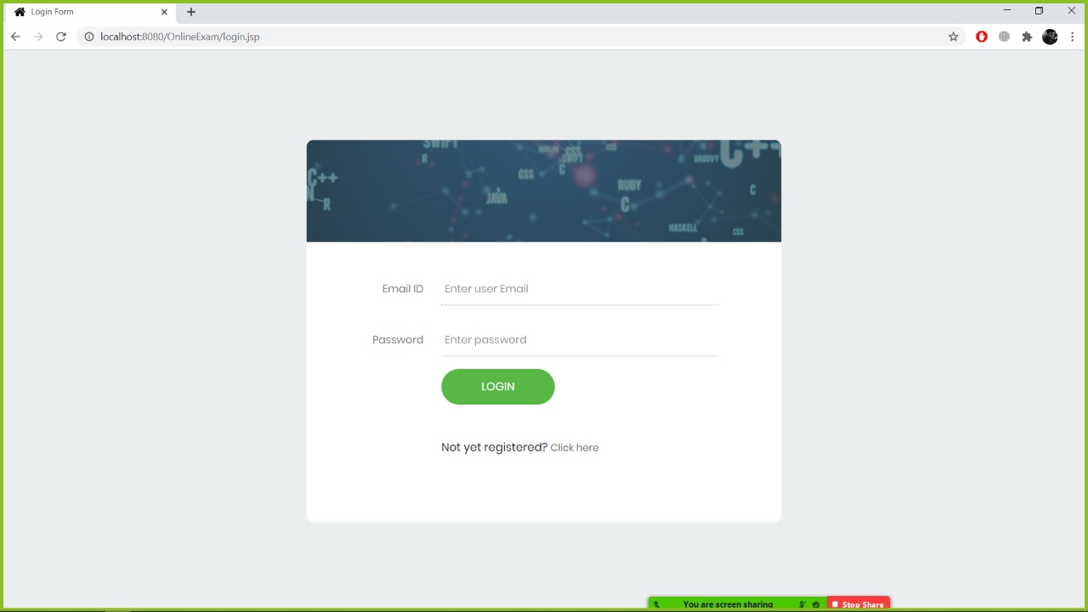

**REGISTRATION SCREEN:**

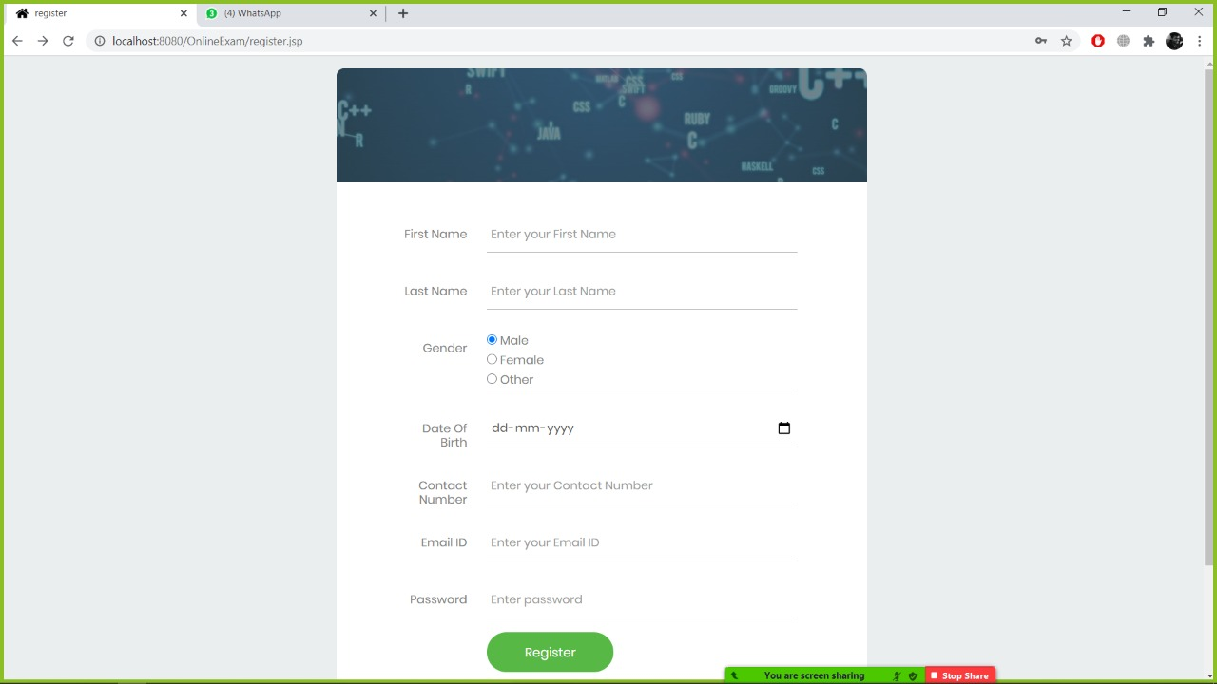

The following reports will be generated:

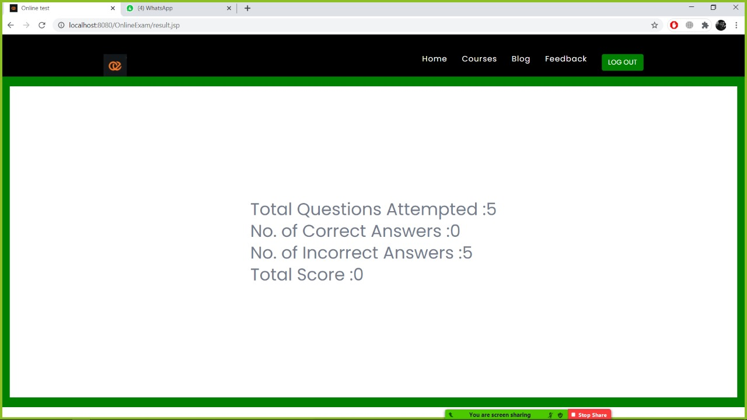

* + - 1. **Hardware Interfaces**
* Processor : intel dual core
* Ram : min 1GB
* Storage capacity : Min 2GB
* Mouse : Standard Mouse
* Keyboard : Regular Keyboard
  + - 1. **Software Interfaces**
* FRONT-END : Sublime text, Visual Code
* BACK-END : Eclipse
* OPERATING SYSTEM : WINDOWS 7/8/8.1/10
  + - 1. **Communication Interfaces**

None

* + - 1. **Memory Constraints**

At least 1GB RAM and 2GB space on hard disk will be required for running the application.

* + - 1. **Operations**

This product will not cover any automated housekeeping aspects of database. The DBA at client site will be manually deleting old/ non required data. Database backup and recovery will also have to be handled by DBA.

* + - 1. **Site Adaptation Requirement**

The terminals at client side will have to support the hardware and software interfaces specified.

* + 1. **Product functions**

The system will allow access only to authorized users with specific roles (Administrator, Operator). Depending upon the user’s role, he/she will be able to access only specific modules of the system.

A summary of the major functions that the software will perform:

(i) A Login facility for enabling only authorized access to the system.

(ii) Users (with role operator) will add/update/delete the stored information and so on

* + 1. **User Characteristics**

1. Educational Level: At least graduate and should be comfortable with English language.

2. Technical Expertise: Should be a high or middle level employee of the organization comfortable with using general purpose applications on a computer.

* + 1. **Constraints**

None

* + 1. **Assumptions and Dependencies**

None

* + 1. **Apportioning Requirement**

Not Required

* 1. **Specific Requirements**

This section contains the software requirements to a level of detail sufficient to enable designers to design the system, and testers to test the system.

* + 1. **External Interfaces**

None

* + - 1. **User Interfaces**

The following screens will be provided:

* + - 1. **Hardware Interfaces**

None

* + - 1. **Software interfaces**

Eclipse   
Visual code

* + - 1. **Communication Interfaces**

None

* + 1. **System Features**

Validity Checks

Sequencing Information

Error Handling / Response to abnormal situations

* + 1. **Performance Requirements**

None

* + 1. **Logical Database Requirements**

The proposed information system contains the following data tables in its database collection.

1. **Login**
2. **Registration table**
3. **Feedback**
4. **Question answer table**
   * 1. **Design Constraints**
        1. **Standard Compliance**

None

* + 1. **Software System Attributes**

Reliability

This application is a reliable product that produces fast and verified output of all its processes.

Availability

This application will be available to use for your end users and help them to carry out their operations conveniently.

Security

The application will be password protected. User will have to enter correct username, password and role in order to access the application.

Maintainability

The application will be designed in a maintainable manner. It will be easy to to incorporate new requirements in the individual modules.

Portability

The application will be easily portable on any windows-based system that has oracle installed.

* + 1. **Other Requirements**

None

**3 Methodologies for Data Collection**

3.1 Primary Data Collection

3.2 Secondary Data Collection

**4. Methodology used for Analysis, Design and Development**

**Prototype Model**

The prototyping model is a systems development method in which a [prototype](https://searcherp.techtarget.com/definition/prototype) is built, tested and then reworked as necessary until an acceptable outcome is achieved from which the complete system or product can be developed. This model works best in scenarios where not all of the project requirements are known in detail ahead of time. It is an iterative, trial-and-error process that takes place between the developers and the users.

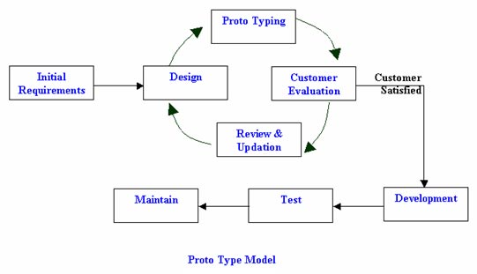

**Fig. 2.1 Prototype Model**

**Stages Involved:**

### Step 1: Requirements gathering and analysis

A prototyping model starts with requirement analysis. In this phase, the requirements of the system are defined in detail.

### Step 2: Quick design The second phase is a preliminary design or a quick design. In this stage, a simple design of the system is created.

### Step 3: Build a Prototype In this phase, an actual prototype is designed based on the information gathered from quick design.

### Step 4: Initial user evaluation In this stage, the proposed system is presented to the client for an initial evaluation. It helps to find out the strength and weakness of the working model.

### Step 5: Refining prototype If the user is not happy with the current prototype, you need to refine the prototype according to the user's feedback and suggestions.

### Step 6: Implement Product and Maintain Once the final system is developed based on the final prototype, it is thoroughly tested and deployed to production.

**Reasons for choosing this model:**

* Simple and easy to understand to use.
* Flexible in design.
* It is easy to detect errors.
* We can find missing functionality easily.
* There is scope of refinement, it means new requirements can be easily accommodated.
* It can be reused by the developer for more complicated projects in the future.

1. **Gantt chart**

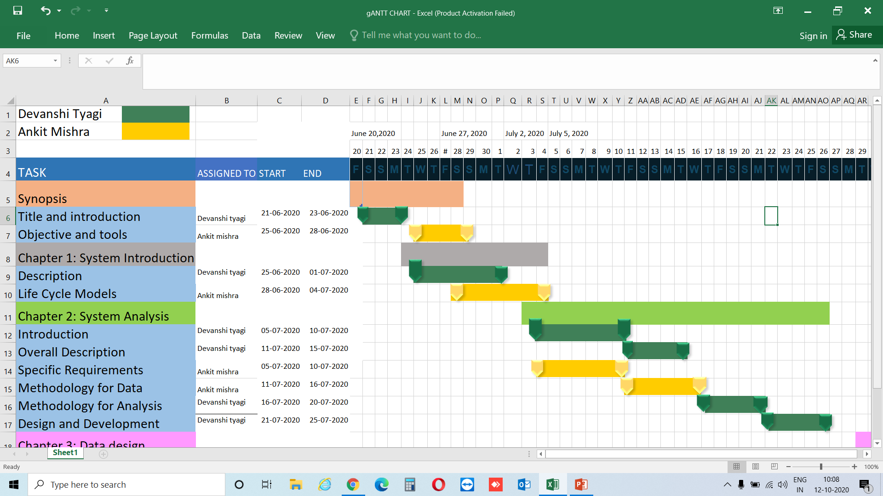

* 1. **Chapter 3:**
  2. **System Design**

**1.Physical Design**

Physical schema (or design) is a term used in [data management](https://en.wikipedia.org/wiki/Data_management) to describe how [data](https://en.wikipedia.org/wiki/Data) is to be represented. The physical design helps us to depict the flow of process, overall view of process, roles of users in a process, relationship of entities in a system, etc. The physical design can be understood by the following diagrams: -

* 1. **2. Block Diagram**

Block diagrams are typically used for higher level, less detailed descriptions that are intended to clarify overall concepts without concern for the details of implementation. In this diagram, the entities, processes and databases are represented by blocks whereas the arrows show the relationships of blocks.

Select course, choose semester, pick the subject accordingly.

TESTS

Login

LOGOUT

User

QUIZ

Register

**Fig.3.1: Block Diagram of Online Examination System**

**3. Use Case**

Use case is a methodology used in system analysis to identify, clarify and organize system requirements. It describes how a user uses a system to accomplish a particular goal.

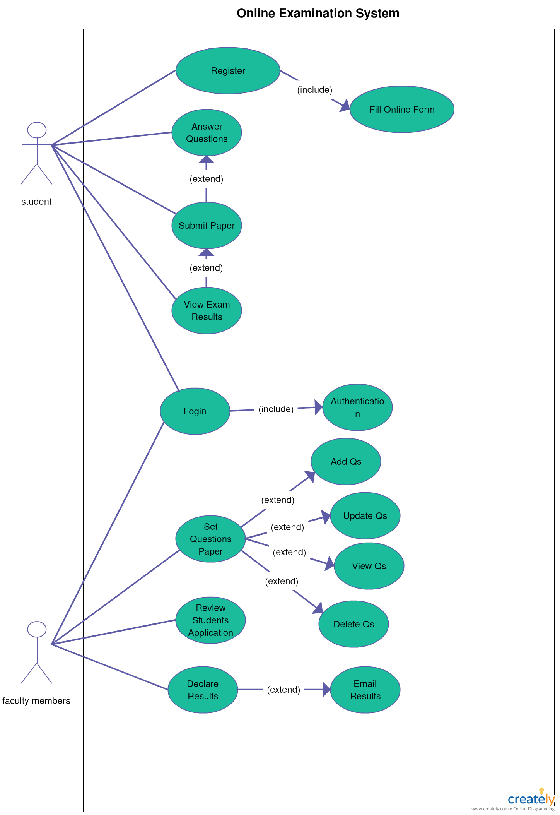

**Fig.3.2: USE-CASE diagram**

1. **DFD**

A data flow diagram (DFD) is a graphical representation of the "flow" of data through an information system, modelling its process aspects. A DFD is often used as a preliminary step to create an overview of the system without going into great detail, which can later be elaborated.

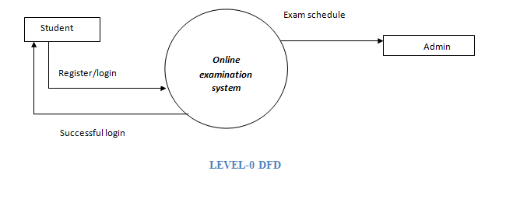

**Fig 3.3: 0-Level DFD for Online Examination System**

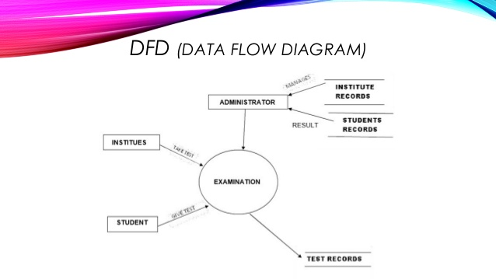

**Fig3.4: DFD for Online Examination System**

1. **ER Diagram**

An entity relationship diagram is a means of visualizing how the information a system produces is related. There are five main components of an ERD:

**Entities**, which are represented by rectangles. An entity is an object or concept about which you want to store information.

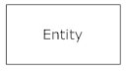

A weak entity is an entity that must defined by a foreign key relationship with another entity as it cannot be uniquely identified by its own attributes alone.

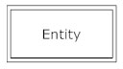

**Actions,** which are represented by diamond shapes, show how two entities share information in the database. In some cases, entities can be self-linked. For example, employees can supervise other Employees.

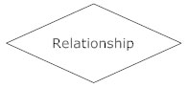

**Attributes**, which are represented by ovals. A key attribute is the unique, distinguishing characteristic of the entity. For example, an employee's social security number might be the employee's key attribute.

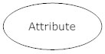

A multivalued attribute can have more than one value. For example, an employee entity can have multiple skill values.

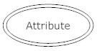

A derived attribute is based on another attribute. For example, an employee's monthly salary is based on the employee's annual salary.

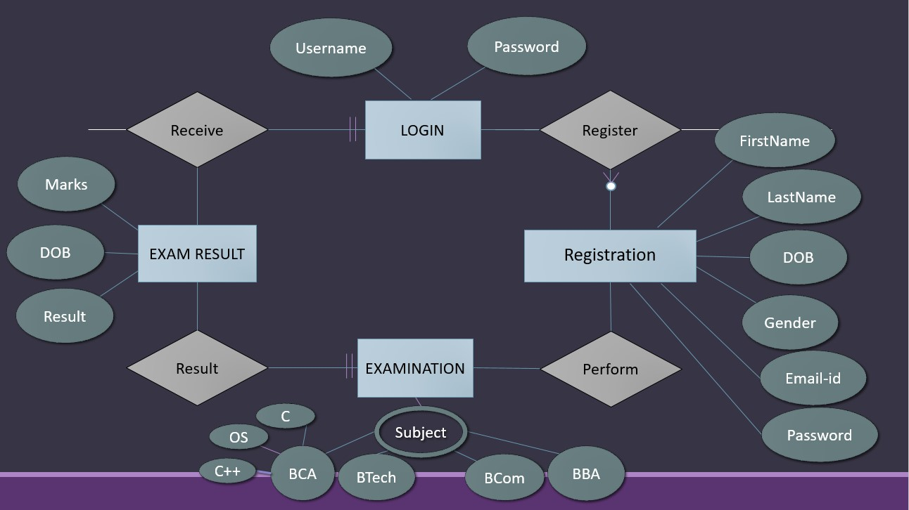

**Fig. 3.5 E-R Diagram for Online Examination System**

1. **Database Design**

The information system of “Online Examination System” performs its function with the help of the data store in certain repositories called Databases of the system. Detailed descriptions of the various databases included in the information systems are tabulated as follows:

**Login table**

|  |  |
| --- | --- |
| Username | Password |
|  |  |

**Registration table**

|  |  |  |  |  |  |  |
| --- | --- | --- | --- | --- | --- | --- |
| FirstName | LastName | Gender | DOB | ContactNumber | Email_ID | Password |
|  |  |  |  |  |  |  |

**Question answer table**

|  |  |
| --- | --- |
| queno | Cans |
|  |  |

**Feedback table**

|  |  |  |  |
| --- | --- | --- | --- |
| Email_ID | Name | Subject | Message |
|  |  |  |  |

1. **Site Map**

A site map (or sitemap) is a list of pages of a web site accessible to crawlers or users. Sitemaps provide site with metadata about specific types of content on your site, including video, images, mobile, and News. For example, a video Sitemap entry can specify the running time, category, and family-friendly status of a video; an image Sitemap entry can provide information about an image’s subject matter, type, and license. You can also use a Sitemap to provide additional information about your site. There are two popular versions of a site map.

* An XML Sitemap is a structured format that a user doesn't need to see, but it tells the  
  search engine about the pages in your site.
* HTML sitemaps are designed for the user to help them find content on the page, and don't need to include each and every subpage.

**Fig.3.6 Site Map**

**3.** **Interface Design**

The interface design consists of the input and output source layouts. i.e. the input forms and screens and the report layouts that form as a source of outcome and income in the design and implementation of the information system under study

**3.1 Input Design**

The input specifications of the existing information system include the illustration of the detailed characteristics of contents included in each Input Screen and documents. The description for each graphical user interface has been mentioned.

EXISTING SYSTEM DESIGN (Graphical User Interface)

1. **Main Form**

**Input screen:**



**Fig. 3.7 Input Screen**

Students or teachers will login on this screen. It takes the data stored from the registration table in the database. It asks you to input your username and password if you are registered and if you are not then you click the link written after ‘not yet registered?’.

**Registration screen**



This screen is for registration. This allows you to input your details (Full name, gender, DOB, Contact number, Email id, Password). It will then be stored in the database. Then it will again ask you to login to enter into the website.

**Main Screen:**

Nav bar shows other webpages like courses blog feedback and two buttons login register

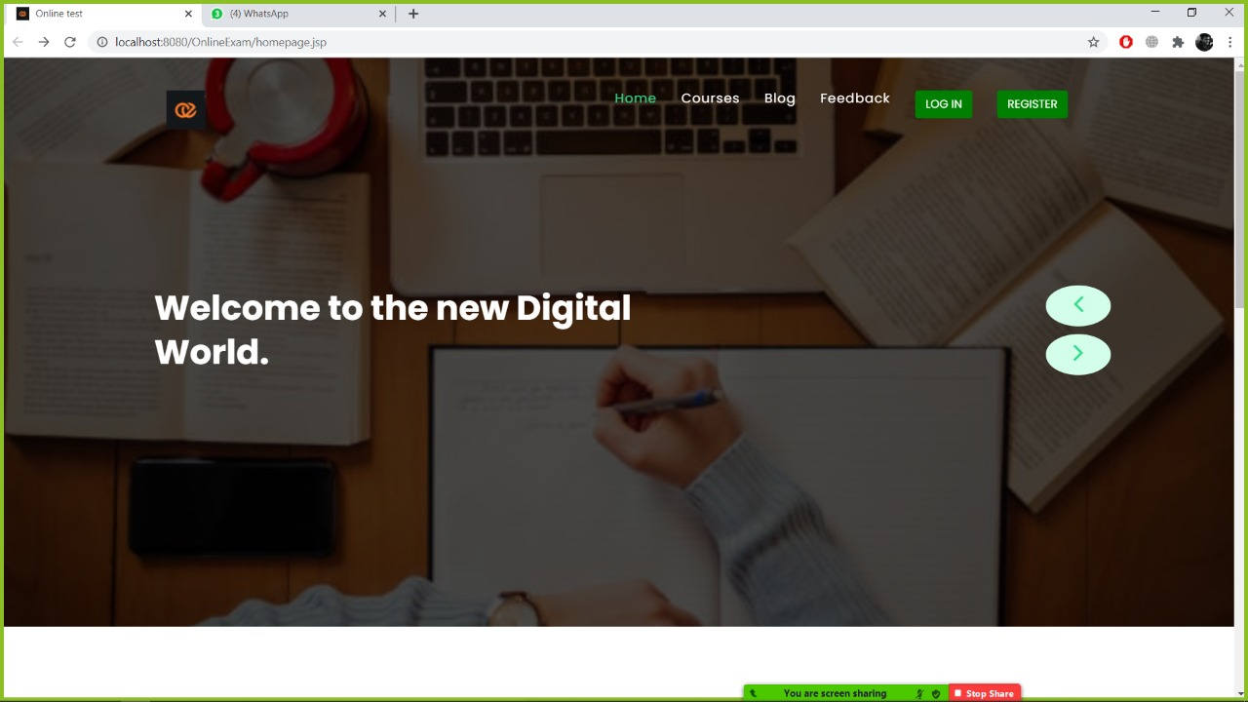

**Courses**

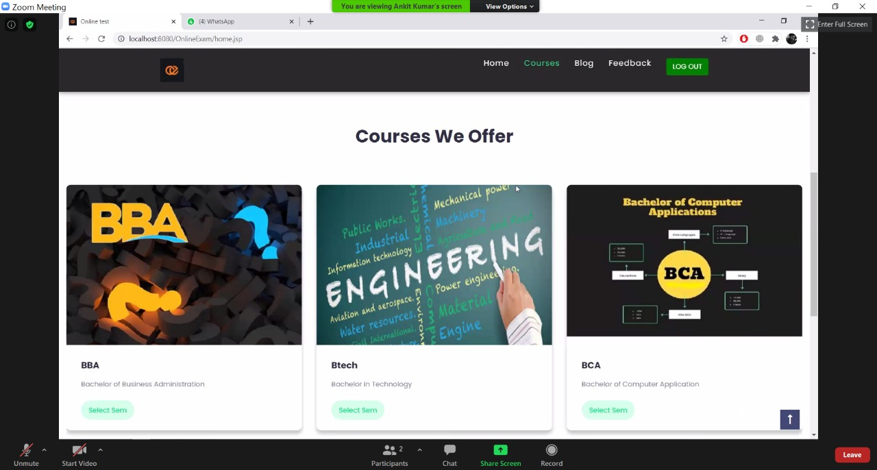

Different types of courses are available on the website.

**Semester**

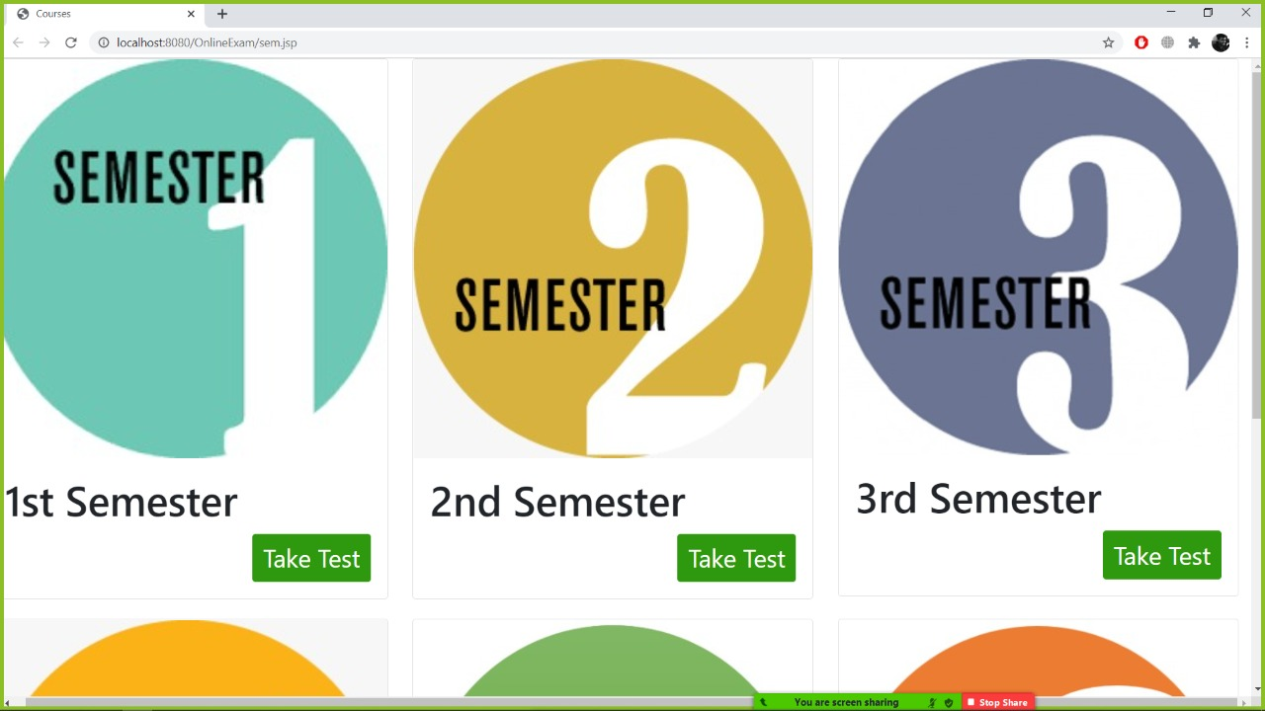

**Subjects**

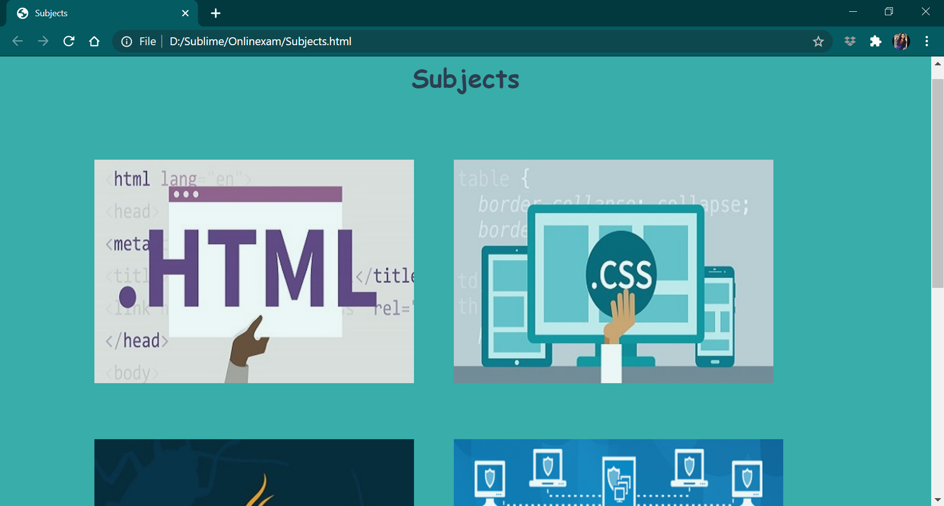

Above screen is showing the subject of the selected semester

**Exam Screen:**

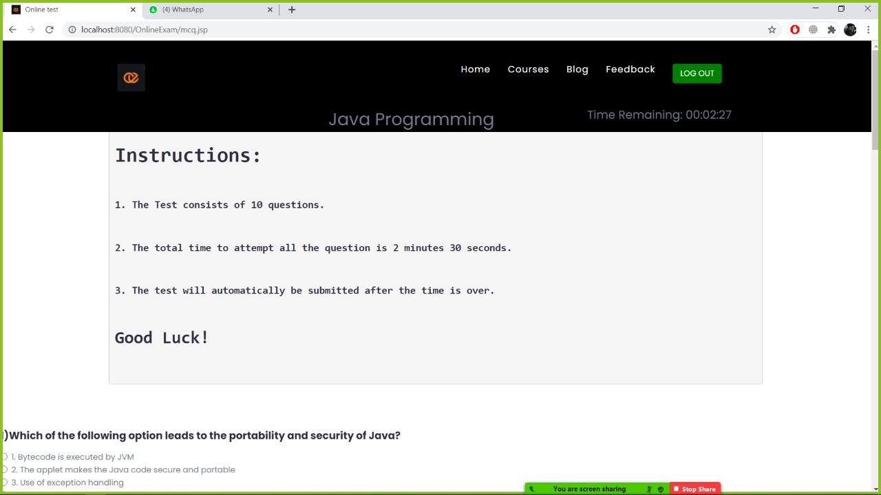

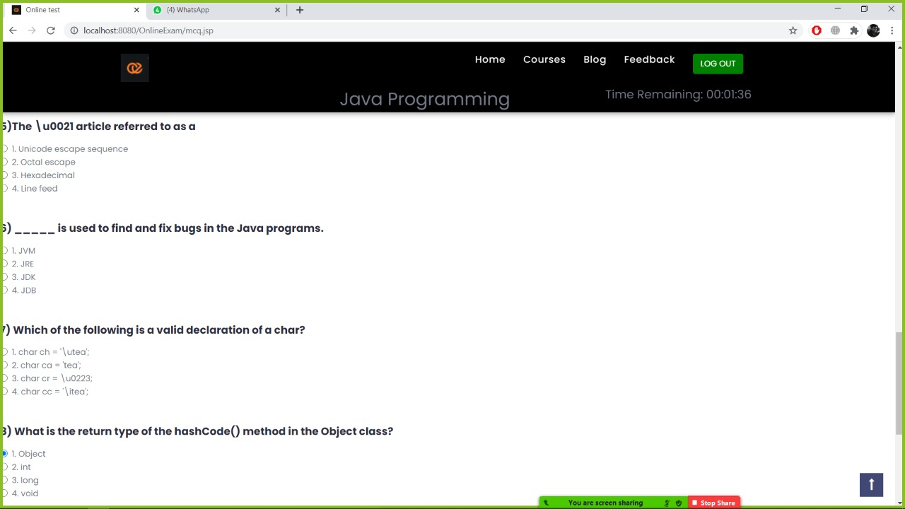

*Above-stated snapshot is the exam screen where students will be given a required amount of time so as to complete the exam. Questions are based on the subject selected. After the students are over and done with their test, their result on the basis of attempted , correct and wrong will be shown to them.*

**3.2 Output Design**

The output specifications of the existing information system include the detailed characteristics of contents included in each Report. The description for each Visual Basic Output Report has been mentioned.

**3.2.1 OUTPUT**



**Fig. 3.8 Output screen**

Result shows up on the above mentioned screen.

**3.3 DATABASE TABLES**

The proposed information system contains the following data tables in its database collection.

1. **Login table**

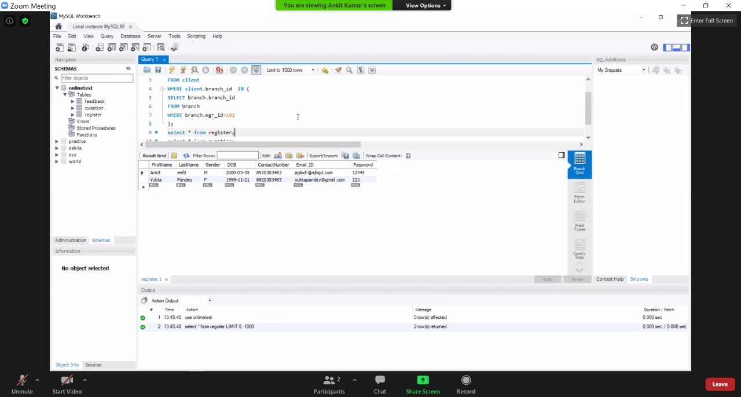

**Table 3.1 Login table**

1. **Registration table**



**Table 3.2 Registration table**

1. **Question answer table**

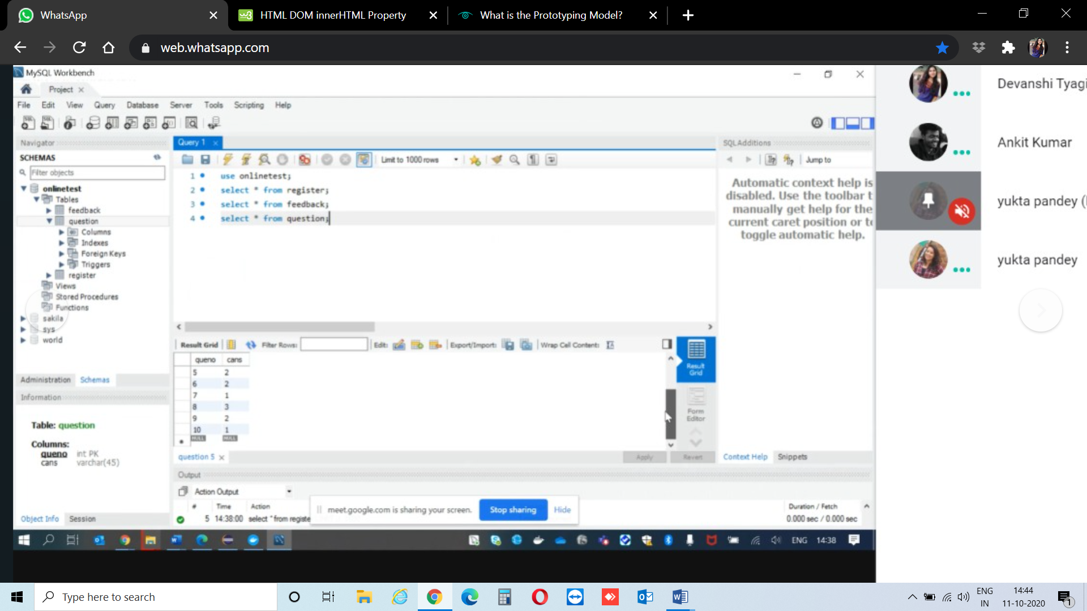

**Table 3.3 Question answer table**

1. **Feedback**

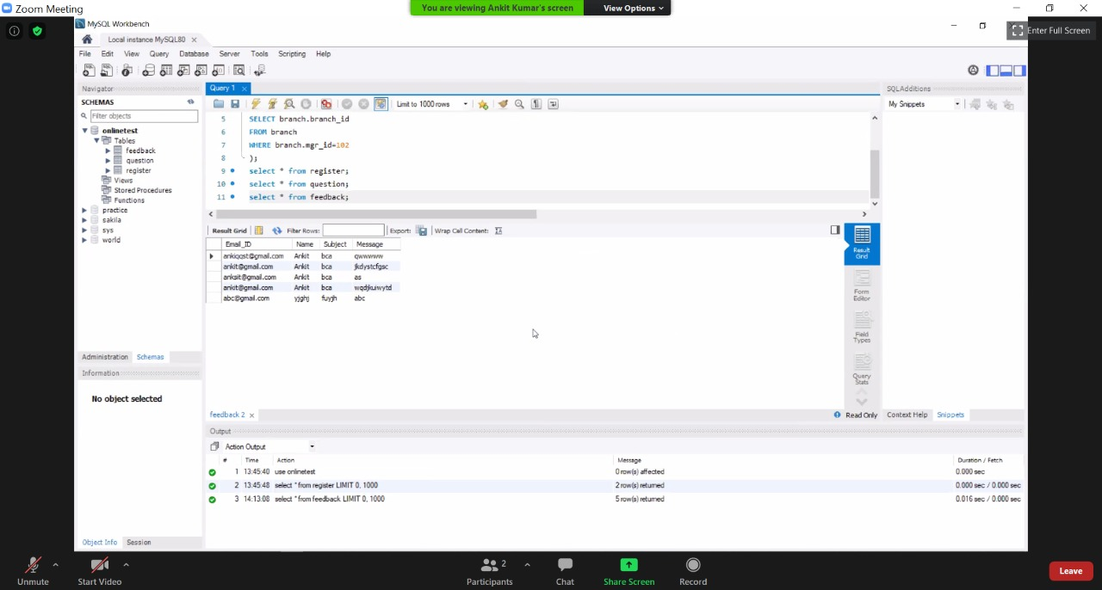

**Table 3.4 Feedback table**